Chapter 13, Problem 23.

If M = 0.2 H and v_{s} = 12 cos (10t) V in the circuit of Fig. 13.92, find i₁(t) and i₂(t). Calculate the energy stored in the coupled coils at t = 15 ms.

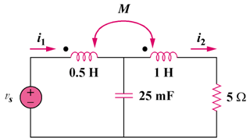

Figure 13.92
For Prob. 13.23.

